Activity 1 for Fundamentals of Algebra Whole Numbers Arithmetic Operations

Part 1A: Recall
Recall that the whole numbers are defined to be $W=\{0, 1, 2, …\}$.
At this point we have classified numbers, learning math vocabulary related to natural counting numbers, and discussed the concept of zero. Now, today’s learning objective explores number operations. What can we do with numbers other than count?
______________________________________________________________________________

______________________________________________________________________________

______________________________________________________________________________

______________________________________________________________________________
Did you know that the Egyptians used large numbers to take census, impose taxes, maintain an army, etc. They used hieroglyphics as a method of writing number symbols. The number one was a single vertical stroke or a picture of a staff (that should look familiar!) What about the number 10? That was a horseshoe picture! $∩$ (Ifrah, 1985)

Part 1B: Symbols and Words
- +
______________________________________________________________________________
______________________________________________________________________________

- -
______________________________________________________________________________
______________________________________________________________________________

- ( ) ( )
______________________________________________________________________________
______________________________________________________________________________

- /
______________________________________________________________________________
______________________________________________________________________________
Assume that there are 2 pineapples in a basket, and you put 4 more in it. Then there will be 6 pineapples in the basket. We say that the sum of 2 and 4 is 6. The operation to find the sum is called addition.

If we want to add two whole numbers, we line up the numbers vertically and add the corresponding digits. For example, we add 213 and 3425 by the following way:

$$3425$$
$$+ 213$$
$$3638$$
We also say that 213 plus 4325 is equal to 3638.

Example: John is attending to a conference in Japan. He goes to a store to purchase a bowl of Japanese noodles for 400 yen and a bottle of mineral water for 120 yen. How much will be the total cost?

Example: Busisiwe lives in Cape Town, South Africa. She wants to visit her friend in Bloenfontein. She also wants to visit her grandparents in Beaufort West which is a city on her way to Bloenfontein. Her total trip is 1005 km. If the distance from Cape Town to Beaufort West is 462 km, find the distance from Beaufort West to Bloenfontein.

Part 1C: Peruvian Ceviche recipe ingredients (Context: Cooking)
- 500 g de camarones (shrimp)
- 250 g de bacalao (cod, fish)
- un jalapeno, diente de ajo, cebolla roja pequeña
- 1 taza de zumo de lima (1 cup lime juice)
- un puñado de cilantro fresco (handful of cilantro)
https://saposyprincesas.elmundo.es/recetas/saladas/recetas-de-cocina-peruana-para-hacer-en-casa/
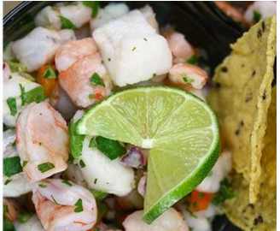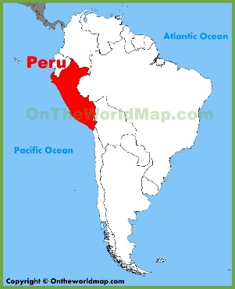

Student Reflections:

- What do you notice about the shrimp and fish measurement?
___________________________________________________________________________
- What issues exist with the cilantro “measurement”?
___________________________________________________________________________
(Be prepared to share thoughts with the whole class…)
Then,
- Translate the instructor request to a math operation for ingredients one and two (shrimp and fish lines)

- Translate the second instructor request to a math operation for ingredients one and two (shrimp and fish lines)

- Summarize the properties of addition, multiplication, division in your words and provide examples.
Verbal: name of property (be specific) | Arithmetic example | Algebraic example | Explain in your words
Addition property of 0 | 3 + 0 = 3 | X + 0 = X

Part 1D: Salaries Activity/Exercise (start in class, then complete as homework)
Clearly print first and last student name:_____________________________________________
DUE DATE: __________________________________________________ at start of class.

Average Salaries US
Websites to explore (depends on occupation, location; vary based on education, gender, ethnicity, etc.)
Bureau of Labor Statistics: (sample of 60,000 eligible households in 50 states)—wage & salary workers. (https://www.bls.gov/news.release/pdf/wkyeng.pdf )

First Quarter 2018
Number of Workers (in thousands)
Men: 64,012
Women: 50,664
1) Total number of workers? _________________

Median Weekly Earnings (seasonally adjusted)
Men: $955
Women: $777
2) How would you figure the average salary overall? _________________________

Other Factors:
Men under 16 to 24 years: $563/wk
Women under 16 to 24 years: $545/wk
3) How much higher are men 16 to 24 years of age paid compared to women in that same age bracket? _____________________________________

Men 25 years & older: $1016/wk
Women 25 years & older: $819/wk
4) How much higher are men 25 years of age and older, paid compared to women in that same age bracket? ________________________________________

Occupations: Median weekly earnings # in 1000s
Management $1229 number: 48,940
Installation/maintenance/repair $924 number: 4,184
Service $567 number: 15,645
5) Create “word” problems related to the occupations information above – be sure to state any assumptions, show work solving your word problem. The goal is to add, subtract, multiply and divide. Problem: ____________________________________________________________________
Work:

2018 updates regarding wages in Mexico:
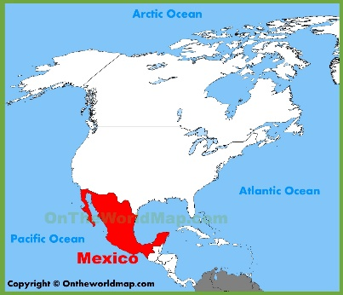
“The Mexican government raised the country's daily minimum salary at the beginning of January, boosting it from 73.04 pesos to 80.04 pesos — or from about $3.52 to $3.86 based on exchange rates at the time.”
For this “whole numbers discussion, we will work with 73 pesos increased to 80 pesos.
- What is the Mexican minimum wage increase in pesos? ______________________________________

(FYI: by end of 2016, 7 million Mexican workers earned minimum wage. It turns out one worker could only afford to buy approximately one third of basic food goods.)
“Mexican laborers worked, on average, a total of 2,246 hours in 2015… But those workers earned on average a total of only $14,867 … US workers labored, on average, for 1,790 hours in 2015, bringing home $58,714.
- What was the average hourly wage in 2015 for Mexican laborers? ________________________

- What was the average hourly wage in 2015 for US laborers? _____________________________

Note: For this division work, we will use “Remainder” whole numbers versus decimals or fractions.

Sources and additional websites:
http://www.businessinsider.com/mexico-wages-incomes-poverty-2017-2
https://elpais.com/internacional/2016/12/08/mexico/1481224214_357441.html
https://en.wikipedia.org/wiki/List_of_countries_by_average_wage
http://news.gallup.com/poll/166211/worldwide-median-household-income-000.aspx

