Module 2: College Algebra Exponential Functions

**Lesson Plan**

**Diversity and Inclusion Objectives**

1. Use students’ interest in contextualized tasks. Get to know your students as individuals and become familiar with the communities in which they live. Connect school to students’ communities and homes and acknowledge that learning occurs in many places
2. Design assessments and assignments with a variety of response types- Use assessments that give students authentic opportunities to demonstrate their understanding
3. Use systematic grading and participation methods
4. Encourage students to embrace a growth mindset
5. Provide a safe and inclusive environment for students to present their knowledge (e.g. Presentation Projects – See “Activity 2” handout) to their peers, and promote peer-to-peer feedback and self-reflection.

**Learning Objectives**

* Describe the difference between constant rate and constant percent rate in identifying linear versus exponential applications.
* Analyze, model and evaluate predictions for real-world applications using exponential functions and their graphs.

**Introduction (5 minutes)**

*Note: when making copies to aid in map copying well, have copier on auto adjust.*

* Remind students of notation regarding bases and exponents, how polynomials have variables in the base and exponentials will have variables as the power.
* Remind students that just like we have a standard format for linear functions that is preferred, , there will be a preferred format for exponential functions.
* Write on the board a slope, or rate, of increase of 10 per year and compare to an increase of 10% per year starting at a particular initial value. Be sure to mention how exponential functions are used to describe many real-world problems from heating/cooling, population, growth and decay, compounding interest, magnitudes of sounds and earthquakes and much more. Exponential functions have the property that the function changes at a *constant percent rate*.

**Explicit Instruction/Teaching Modeling (20 minutes)**

* Provide a copy of the student handout, and project a copy to be filled out with the students.
* Allow time for students to fill in the missing values in the tables for population growth just by using the data provided, not with an explicit exponential function.
* Have students explain if the growth has a constant rate, or a constant percent rate.
* When starting the credit card application, be sure to talk about the assumptions being made – that the balance is not paid off, which is not necessarily unrealistic if you charge, and make payments at the same time. Have students look at the growth of the amount and comment on any trends. Be sure to mention that savings and investment accounts work on the same principles so students can take advantage of compound interest even with small sums of money. The activities for this lesson will further address these issues.
* Discuss the general terminology, and have students contribute to the discussion – include ideas of domain, range, concavity, growth, decay, intercepts, and asymptotes.
* After working through the population growth example (revisited), allow students to work through the decay problem on their own.

**Guided Practice/Interactive Modeling (20 minutes)**

* Use the handout as guided notes and practice for students during the lesson.
* After completing the population growth example, have students discuss examples of when interpolation, and when extrapolation of the data would be needed. Have them go beyond just needing the specific year. Provide contexts that include census data, government funding, sales demographics, and other real-world contexts that rely on population/demographic data.
* The second application looks at credit cards. As either a pre-class meeting exercise or at the beginning of the section, help students get a frame of reference by watching and analyzing the video from the site [The Lowdown | The Math of Credit Cards](https://cet.pbslearningmedia.org/resource/mkqed-math-rp-creditcards/the-math-of-credit-cards/#.WzoKC9JKjIW). The direct link to the video is here: <https://www.youtube.com/watch?v=L5qlbISOAGA>. In either approach, have students offer feedback and present key concepts for about 5 minutes. A feedback form is included on the list of items provided on the site [The Lowdown | The Math of Credit Cards](https://cet.pbslearningmedia.org/resource/mkqed-math-rp-creditcards/the-math-of-credit-cards/#.WzoKC9JKjIW) and is also attached at the end of this document. You can summarize the financial implications and daily budgeting (i.e. to-dos and to don’ts to avoid falling into a deep, exponentially growing, financial debt, named as “blackhole debt”).
* After presenting the credit card example, allow time for students to use the website provided in the problem to determine how long it will take to pay off a credit card, if someone only pays the minimum. Have students work together and discuss their perceptions. For question (3), students should be able to convert from months to years.
* Students should work through the radioactive decay problem on their own. Part (c) may be difficult. It will be important to reinforce that there are multiple methods to reach the answer – trial and error, graphically, or using logarithms. Here, one can point out that we can solve using logarithms and will be presenting that material in future sections.

**Activities (20 min)**

* Students should work through the radioactive decay problem on their own. Part (c) may be difficult. It will be important to reinforce there are multiple methods to reach the answer – trial and error, graphically, or using logarithms. Here can point out that we can solve using logarithms and will be presenting that material in future sections.

**Assessment**

* In-class activities and presentation projects (see Activity 2 handout) can serve as a tool for informal assessment. The instructor can choose to use a well-defined rubric for the in-class presentation project. This rubric needs to be shared with students in advance. As a follow up, the instructor might need to provide a detailed feedback to each group of presenters, on both presentation skills, and content knowledge.

**Review and Closing**

* Recap the components of this unit by reviewing the chart in the guided practice section or problems from their independent practice.
* Allow students to comment and ask any additional questions.
* Ask students why they think it is important to know this information.

***Exponentials Module***:

Most of the functions you have dealt with have been polynomial functions, with a few others involving roots or powers. These types of functions are called algebraic functions because they can be described in terms of addition, subtraction, multiplication, and division. We are now going to look at a different type of function, where the variable is not the base in the equation, such as in, but the variable is the power, like .

Exponential functions are used to describe many real-world problems from heating/cooling, population, growth and decay, compounding interest, magnitudes of sounds and earthquakes and much more. Exponential functions have the property that the function changes at a *constant percent rate*.

Before we consider exponential function in more detail let’s look at some applications where exponentials are useful. We will look at population growth, credit cards, and Radioactive Decay – believe it or not they are mathematically related!

***Population Growth:***

When thinking about exponentials population growth is one of the first natural applications. Consider the following questions and how modelling with exponentials would be applicable.

|  |  |
| --- | --- |
| * What’s the population of the whole world? Of the United States? * How many languages in the world? How many are spoken in the United States? | * How many ethnicities in the world? In USA alone? * Why is the ideas in these questions important to understand for mathematical applications? |

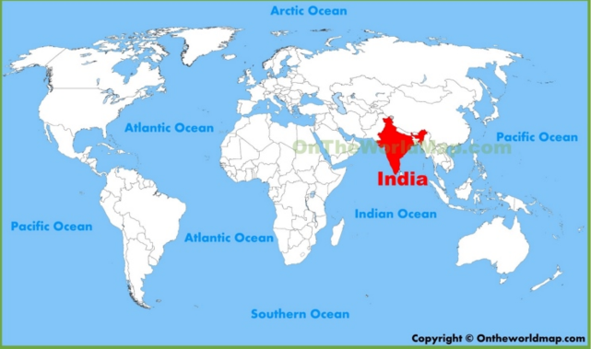Let’s consider the country with fastest growing population, and a multi-ethnic and linguistic background - India. The current estimate for the population growth of India is 1.11% per year.

As of 2018, the population of India accounts for 17.74% of the world population. The United States accounts for 4.28%. (Source: <http://www.worldometers.info/world-population/population-by-country/>)

Below is a table that gives the population of India in years since 2000. (This means  corresponds to the year 2000.) A plot of the data points is also provided.

From http://ontheworldmap.com/india/india-location-map.html

|  |  |
| --- | --- |
| *t*, years  since 2000 | Population of India in billions of people |
| 0 | 1.0530 |
| 5 | 1.1441 |
| 10 | 1.2310 |
| 15 | 1.3091 |
| 16 | 1.3242 |
| 17 | 1.3392 |
| 18 | 1.3541 |
| 19 |  |

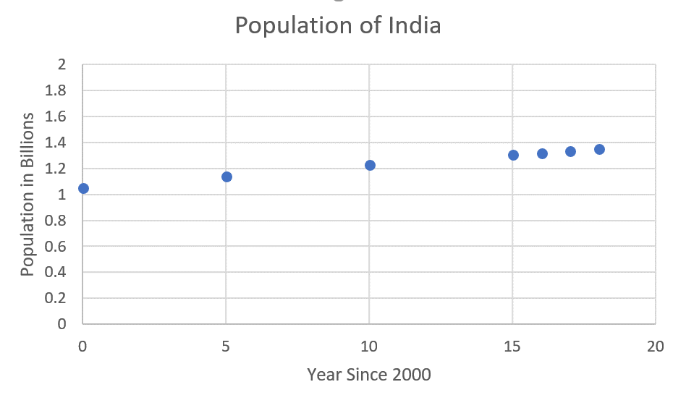

Note that the points might seem to follow a linear path, but if so the rate of change, or slope, would be constant. This would mean the same number of people would be added to the population per year. Does this make sense for this real-world problem? In fact, at the start of this section it was stated that the population is not growing at a constant rate, but at a constant *percentage rate*. 1.11%. This is an important difference. This would mean the larger the starting population, the more you would add per year.

*Example 1:*

1. Using the value for 2018, estimate the value for 2019 given the growth rate of 1.11%, and fill in the chart.

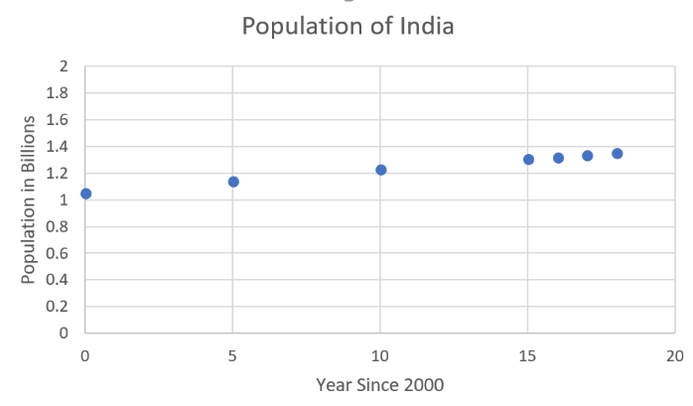Notice the data points in are plot are not all evenly spaced. This is how data is often given. In our interest to model and predict, we can estimate the values in between. Determining the values in between data points is called interpolation, while predicting future events is extrapolation.

1. Given the population example for the population of India, consider interpolation and extrapolation. Give an example of an application where you might need interpolation and give a second example where extrapolation would be necessary.

Constant percent rates lead to exponential functions…so populations tend to be modeled using these exponential functions. Another real-world application involving constant percentages is credit cards.

***Credit Cards:***

For our next application, we will look at how credit cards work. For an overview of the topic, what the video at the site <https://www.youtube.com/watch?v=L5qlbISOAGA>. While watching the video, fill out *The Math of Credit Cards Discussion Questions Handout* provided to you. We will discuss these questions and will think about how exponentials will help us model these real world applications.

Credit card companies offer a way to take a small loan with interest, depending on if you pay off the full amount charged. If you don’t pay the full amount on your credit card each month, you have to pay a fee, which is based on a percentage of the loan. According to the site cardrates.com, in 2018 the average cardholder has approximately $4,789 in credit card balances. The average annual percentage rate on a credit card is 16.2%. To simplify our discussion, consider the table below where the balance of $4,789 grows at 16.2% per year.

|  |  |
| --- | --- |
| *t*, years | Balance in dollars  (Interest + Previous Balance) |
| 0 | 4789 |
| 1 | 5564.82 |
| 2 | 6466.32 |
| 3 | 7513.86 |
| 4 | 8731.11 |
| 5 | 10145.58 |
| 6 | 11789.13 |
| 7 | 13698.96 |
| 8 | 15918.20 |
| 9 |  |
| 10 |  |

***Try****:* Fill in the values for year 9 and year 10 in the table to the right.

You can see how the graph has a “bend” and does not follow a straight line. You might also be thinking - well someone will pay the minimum required so it will not exponentially increase…What happens if you only pay the minimum payment required?

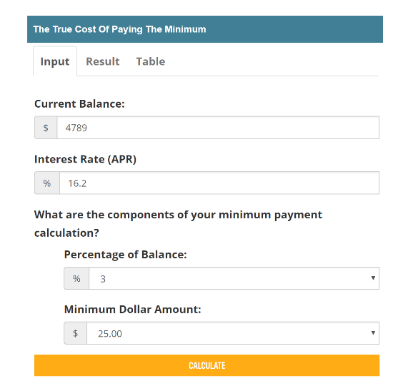*Example 2*:

* 1. Go to the website <https://www.creditcards.com/calculators/minimum-payment/> and change the balance to 4789 and the APR to 16.2, leaving all other items alone. How long will it take to pay off the debt, assuming you do not charge anything new?
  2. Click on the “Table” link to see how the payment is broken down. What is the total interest paid at 100 payments according to the table?
  3. According to the table, how many ***years*** will it take to pay off the credit card?

Also note that you can take advantage of the same process as a consumer when investing money! This is the concept behind *compound interest*, which we will consider in the activities for this section. Let us look at the bigger picture and consider the general form of exponential functions.

***Exponential Functions:***

An exponential function is written



where *a* is the initial value, ,and *b*, the base, is the growth factor or decay factor (also called the constant multiplier), .

Consider the graphs for  below with .

|  |  |
| --- | --- |
| 1. For this graph we also have  (For example  ) Label some key features of the graph. | 1. For this graph also have  (For example  ) Label some key features of the graph. |

For an exponential function,  the value of *b* will depend on whether the quantity is growing or decaying. If *r* is the rate, then the value of *b* is given by: . Or the percent rate *r* can be found using .

*Example 1:* For exponential model given, determine the initial value and the percent rate.

1.  b)

*Example 2:* Recall from the first page that the population of India in 2000 was 1.0530 billion. The population was also growing at a rate of 1.11% per year.

1. Find an exponential function that will model the population of India since the year 2000.
2. Using the model found in part (a) interpolate the population for the year 2012.
3. Using the model found in part (a) predict the population for the year 2020.

In the next example we will consider radioactive decay, a natural process by which an element/compound breaks down. For exponential decay recall that , so is the rate, *r*, positive or negative for decay?

*Example 3:* Technetium is used as a medical tracer, as it is an element that can be readily detected in the body by medical equipment. It is used in a wide range of medical applications, including distinguishing brain tumors. The three largest suppliers of the medical tracer are Canada, Australia, and South Africa. Suppose the amount of Technetium-99m used for a particular medical procedure can be modeled by



where *A* is measured in milligrams and *t* is in hours.

1. What can you conclude about the initial amount of the sample?
2. Determine the rate of decay.
3. How long will it take before you only have half of the sample left? (This is called the half-life of the sample.)

**Sources and Additional Websites**:

* <http://www.worldometers.info/world-population/population-by-country/>
* <https://cet.pbslearningmedia.org/resource/mkqed-math-rp-creditcards/the-math-of-credit-cards/#.WzmwbqknYdW>
* <https://www.creditcards.com/calculators/minimum-payment/>

Video link: <https://www.youtube.com/watch?v=L5qlbISOAGA>



1. When you use a credit card, where does the money come from to pay for the goods you are getting?
2. What is a line of credit?
3. What are the options for paying back a credit card loan?
4. What is a minimum payment?
5. What is interest?
6. How do credit card companies make their money?
7. What are payday loans?
8. Why do credit card companies not like people who are considered “dead beats”?
9. What are the main lessons or advice given in the video?